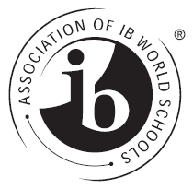
Texas IB Schools
P.O. Box 918, Colleyville, Texas, 76034

Membership Invoice 2023-2024

TO: ______________________________________________________ (School Name)
FROM: Texas IB Schools
DATE: August 14, 2023

Payment type:
☐PO: _______________
☐Check #: ___________

Quantity Description Price
1 TIBS Membership Dues 2023-2024 $300.00
Dues are $300 per IB program per school.

Make check payable to: Texas IB Schools
(please include a copy of this invoice with all checks)

Mail to: Texas IB Schools
Attn: Sherri Rosse
P.O. Box 918
Colleyville, TX 76034

Please fill out one form per IB program per school & include it with the check.

School Name__________________________________________________________
ISD _________________________________________________________________
Address______________________________________________________________
City_________________________________________________________________
ZIP _________________________________________________________________
Coordinator’s Name____________________________________________________
Coordinator’s E-Mail Address____________________________________________
Please Indicate (please circle): Private Public Charter
IB Program (please circle): PYP MYP DP IBCP
IB status (please circle): Interested Candidate Authorized
Membership Status (please circle): Returning New

