Spicewood Elementary Innovative Schools Grant Evaluation
In early August of 2017, our campus participated in Kagan Cooperative Learning Day 1 professional development. This unique training provided our teachers with a variety of structures and strategies (known as the Kagan essential 5) to implement in their classrooms that give all students an opportunity to be engaged in the classroom learning and conversation.
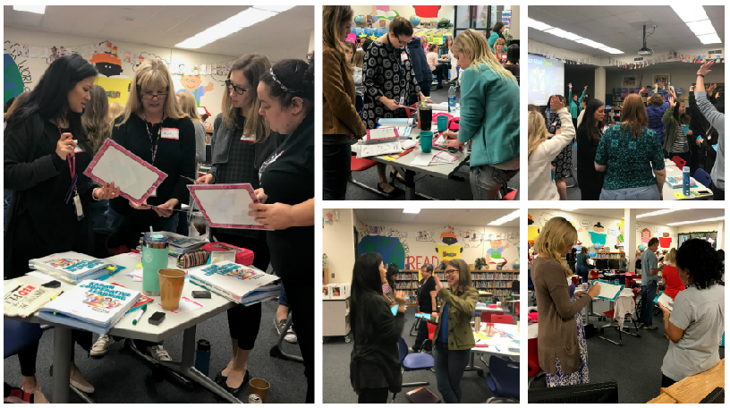
As the teachers slowly began implementing these structures in their classrooms, they saw that their classes quickly created communities (something essential for the start of a school year!) by building teams that engaged all different types of learners. With these structures, students share thoughts, ideas, and answers with one another, requiring an amount of trust between themselves and their peers. Teachers noted that their classes worked more cohesive as a team more quickly in the year due to the use of these structures. Teachers also shared that these structures not only provided data to help drive instruction, but also that students were more actively engaged and “owned” their learning. Teachers saw evidence of this in student questioning, answers, and overall enthusiasm and engagement on a daily basis.
Teacher reflections…
- “Implementing Kagan structures helps me take that step back as a teacher and allow the children to take more control of their learning. I enjoy listening in on their conversations. It gives me a great picture of where each student is in the learning process and how much knowledge they've retained.”
- “They have transformed my teaching, increasing my students participation in almost every learning experience. Kagan structures have guided me into less direct teach to more interactive teaching.””
- Kagan has brought new ideas, has got more of my students talking, and I've seen more reserved students be engaged with the learning. It makes me excited to see how engaged my students are. It also gives me new ideas to make teaching fun.”
- “My students have been more engaged in learning. Giving new structures get my students excited and talking about their learning. They are able to be interacting with each other, moving around, getting their brains moving. I've seen my students improve on their social skills, and group decision making skills from using Kagan Structures.”
- “Students have had more opportunities to share their thinking and to hear other student's thinking. They love that it is equal amounts rather than one partner always doing all of the talking. I feel that Rally Coaching has improved the dynamic of our relationships and feelings allowing students to understand and realize that we have several teachers within our classroom, not just me. It has also helped me structure team and class building activities rather than having to search for them on my own time.”
